Female Donor Physical Examination

Instructions for use: FDA requires that a physical examination be performed and documented to assess a donor for signs of a relevant communicable disease and for signs suggestive of any risk factor for a relevant communicable disease. FDA has provided specific guidance on what clinical and physical evidence to look for when screening a donor (http://www.fda.gov/cber/gdlns/tissdonor.htm). Utilization of this form will assist you in documenting such clinical and physical evidence. A donor should be determined to be ineligible if they exhibit physical evidence of relevant communicable disease or high-risk behavior associated with these diseases.

Donor Name or Distinct ID Code _____________________________________
Date of Birth____________________

Photo Identification_______________________________________
ID Checked by___________________________________________

Type of Cells / Tissues Donated ________

Date of Examination_______________
Vitals: Height _______ Weight _______ Temperature _______ Pulse _______ Respiration _______ BP _______
Any changes in health status? Y N Any changes in social behavior? Y N

Neurological _____Normal (no signs of dementia) _____Abnormal

Eyes ______ Normal _____Abnormal
- Any infection or redness of the eyes related to possible cornea abrasion or scarring consistent with vaccinial keratitis? _____Yes _____No
- Icterus? _____Yes _____No (if yes, answer may not result in donor ineligibility if cause of Icterus is other than infectious disease)

Throat _____Normal _____Abnormal
- Any oral thrush, white spots or unusual blemishes? _____Yes _____no

Lymph nodes _____Normal _____Abnormal
- Any swollen lymph nodes in the neck, axilla, or groin or evidence of disseminated lymphadenopathy? _____Yes _____No

Abdomen _____Normal _____Abnormal
- Any tenderness or hepatomegaly? _____Yes _____No (if yes, answer may not result in donor ineligibility if cause of hepatomegaly is other than infectious disease)

Breasts _____Normal _____Abnormal ____________________________________________________________

External Genitalia _____Normal _____Abnormal __________________________________________________

Vagina / pelvic support _____Normal _____Abnormal _______________________________________________

Cervix _____Normal _____Abnormal ____________________________________________________________

Uterus _____Normal _____Abnormal _____________________________________________________________

Bladder _____Normal _____Abnormal ___________________________________________________________

Urethral Meatus _____Normal _____Abnormal ____________________________________________________

Urethra _____Normal _____Abnormal _________________________________________________________
- Any redness, edema, or physical evidence of genital ulcerative disease, herpes simplex, syphilis, genital warts, or chancoid? _____Yes _____No
- Any physical evidence of anal intercourse, insertion trauma, or perianal condyloma? ____Yes ____No

Pelvic Ultrasound

Uterus _____Normal _____Abnormal ___________________________________________________________

Ovary (Right) _____Normal _____Abnormal Antral Follicle count__________________________________

Ovary (Left) _____Normal _____Abnormal Antral Follicle count__________________________________

Skin _____Normal _____Abnormal
- Evidence of non-medical percutaneous drug use? _____Yes _____No
- Purple/blue spots consistent with Kaposi’s Sarcoma _____Yes _____No
- Jaundice _____Yes _____No (if yes, answer may not result in donor ineligibility if cause of Jaundice is other than infectious disease)
- Evidence of Icterus _____Yes _____No
- Rashes _____Yes _____No
- Large scab or necrotic lesion consistent with recent smallpox vaccination or vaccinia necrosum _____Yes _____No
- Lesions or eczema vaccinatum _____Yes _____No

Tattoo (s) _____Yes _____No
- Any evidence of recent (12 months) tattoo or home produced tattoo? _____Yes ____No

Body or Ear Piercing ____Yes ____No
- Any evidence or recent (12 months) piercing? ____Yes ____No

Donor Physical Examination

Donor Name or Distinct ID Code___________________________

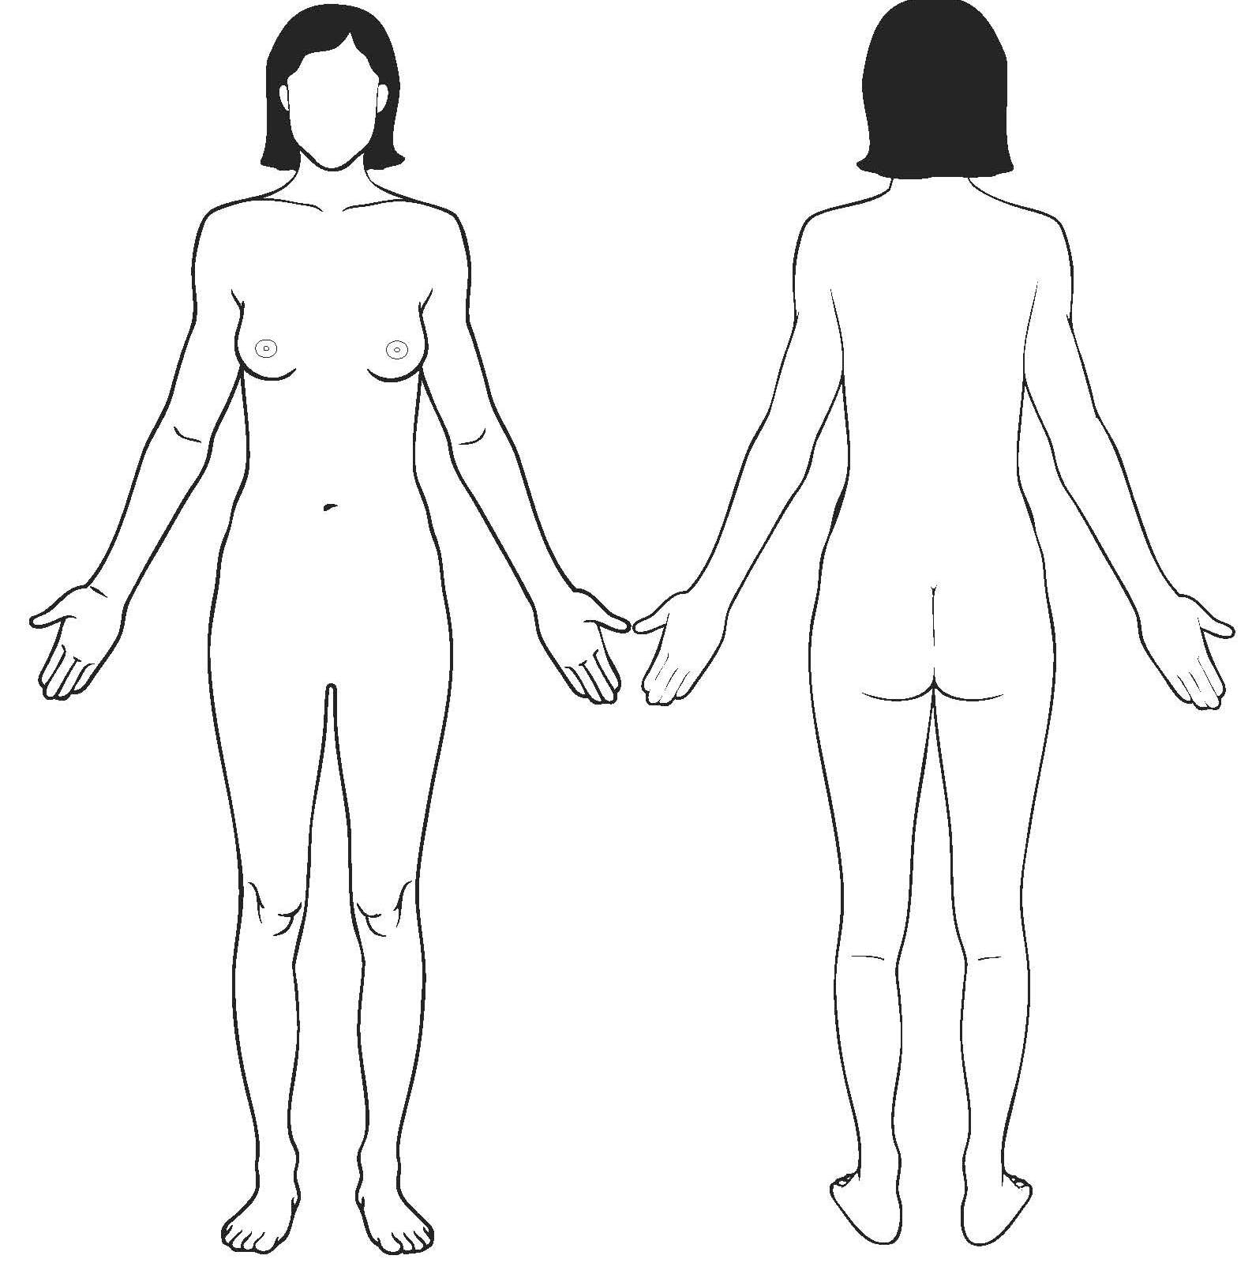

Please mark the location of any rashes, scars, lesions, tattoo(s), piercing(s), needle tracks or hematomas.

Authorized Medical Provider Completing Form:

_________________________ ________________________ _______________
Print Name & Title Signature Date

